# Main.java

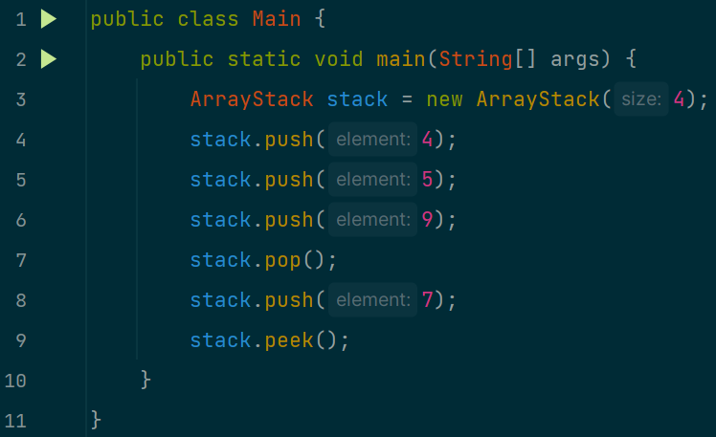

# ArrayStack.java

# OUTPUT

